**Version 23.1.0 for year 2023**

­



**Table of Contents**

1. Summary 1

2. Component Overview 1

2.1 Functional Overview 1

2.2 Use Cases 1

2.2.1 Jobs 1

2.2.2 Tracking ID 1

2.3 Compatibility 2

2.4 Privacy, Payment 2

2.5 Limitations, Constraints 2

3. Implementation Guide 2

3.1 Setup 2

3.2 Configuration 2

3.2.1 Installing the cartridge(s) 2

3.2.2 Configure Shopping Gives preferences 3

3.2.3 Order Export Status to Export 6

3.2.4 Configure Product Associated Group ID and Product Tags ID 6

3.2.5 Configure Shopping Gives Service Credentials 6

3.3 Custom Code 8

4. Operations, Maintenance 8

4.1 Data Storage 8

4.2 Availability 8

4.3 Failure/Recovery Process 8

4.4 Support 8

5. User Guide 9

5.1 Roles, Responsibilities 9

6. Known Issues/Caveats 9

7. Release History 9

# Summary

This document provides the guidelines for the implementation of the Shopping Gives Controllers enabled cartridge to SalesForce Commerce Cloud (SFCC).

# Component Overview

## Functional Overview

This cartridge covers the following Shopping Gives jobs Order Feed Export Full, Order Feed Export Delta, Product Feed Export Full, and Product Feed Export Delta.

## Use Cases

## Jobs

Shopping Gives cartridge supports 4 optional jobs that are imported in the metadata.

* **OrdersFeedExportFull** is a job that will gather all orders for a site.
* **OrdersFeedExportDelta** is a job that will gather all orders after the date of the last order feed job for a site.
* **ProductsFeedExportFull** is a job that gathers all the products within a site.
* **ProductsFeedExportDelta** is a job that will gather all products after the date of the last product feed job for a site.
* Each process as described above packages its data as an XML file.

## Tracking ID

Shopping Gives tracking id will be retrieved from the session storage of the browser and will be stored inside the order level custom attribute.

***IMPORTANT: To run these jobs, you must have specific values in the Shopping Gives Custom Preferences that will be given to you by your Shopping Gives Success.***

**Multiple Sites/Locales**

The Shopping Gives LINK cartridge supports multiple Sites and multiple languages/locales within those Sites. The ShoppingGives-ExportProducts job can be set to run for multiple Sites. Additionally, in the Job configuration, the locale for export can be specified as a job parameter. If not specified the Site default locale will be used. Multiple job steps (or separate jobs) may be configured to support additional site locales.

## Compatibility

Shopping Gives compatibility mode is 22.7 and Site Genesis version is 105.2.1

## Privacy, Payment

There are currently no privacy or payment issues.

## Limitations, Constraints

There are no known limitations or constraints.

# Implementation Guide

## Setup

The following ShoppingGives Integration tasks are included within the LINK Cartridge:

1. Installation of the cartridge
2. Import custom metadata
3. Set the newly-created metadata values (Site Preferences)
4. Import or create Product and Order feed job(s)
5. Make storefront cartridge edits

## Configuration

## Installing the cartridge(s)

* **Import the int_shoppinggives_sg cartridge into the Commerce Cloud Studio Workspace:**

Open Commerce Cloud Studio

Click File -> Import -> General -> Existing Projects Into Workspace

Browse to the “int_shoppinggives_sg” directory

Click Finish.

Click OK when prompted to link the cartridge to the sandbox

* **Assign cartridge to Business Manager**

Log into Business Manager

Click Administration -> Sites -> Manage Sites -> Business Manager Site

Select the “Settings” tab

Add “int_ shoppinggives” to the beginning of the cartridge path.

Click Apply

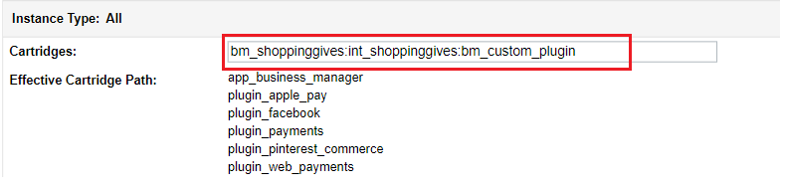

* **Assign cartridge to site**  
  Log into Business Manager  
  Click Administration -> Sites -> Manage Sites -> SiteGenesis or required site  
  Select the “Settings” tab  
  Add “int_shoppinggives_sg” , “int_ shoppinggives _sg_changes” “bm_shoppinggives” and “int_ shoppinggives” to the beginning of the cartridge path (or ensure it is in front of app_storefront_base  
  Click Apply

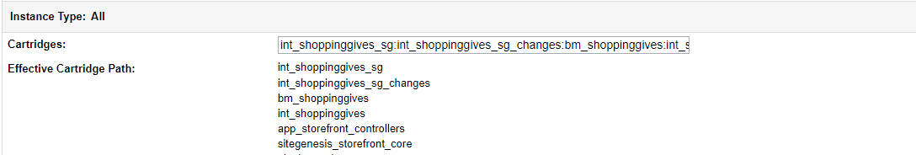

* Re-activate the current code version (on sandboxes). This may be necessary to ensure the custom job steps are available. Click [Administration](https://dev01-na01-luxurybrandholdings.demandware.net/on/demandware.store/Sites-Site/default/ViewApplication-ExpandMenuGroup?MenuGroupID=AdministrationMenu&OverviewPage=SiteNavigationBar-ShowAdministrationOverview&csrf_token=gV0CPCPqzbUWM_Y7xLVOkzpmo1l3wBw25A_Jz3QemO2H3jn8SJgyYhC_-ULx9nuKFeGuted4OXcL_RAmnAplrdfg2nnyEvQR6hx-Elu8uxJwk064aB-RYaggWSSrZDjOvpBYk7RSPYGp-EOqraLoaTVAZM5p7KUjiIV0JHwNeYZL4l_iaRw) > [Site Development](https://dev01-na01-luxurybrandholdings.demandware.net/on/demandware.store/Sites-Site/default/SiteNavigationBar-ShowMenuitemOverview?CurrentMenuItemId=studio&csrf_token=gV0CPCPqzbUWM_Y7xLVOkzpmo1l3wBw25A_Jz3QemO2H3jn8SJgyYhC_-ULx9nuKFeGuted4OXcL_RAmnAplrdfg2nnyEvQR6hx-Elu8uxJwk064aB-RYaggWSSrZDjOvpBYk7RSPYGp-EOqraLoaTVAZM5p7KUjiIV0JHwNeYZL4l_iaRw) > Code Deployment Activate a different code version from the currentActivate desired code version

## Configure Shopping Gives preferences

In Business Manager, navigate to the target Site > Site Preferences > Custom Preferences.

A custom site preference group with the ID **ShoppingGivesConfigs** is available. Please select it and edit the attributes accordingly.

|  |  |
| --- | --- |
| **Preference Name** | **Description** |
|  |  |
| ShoppingGives Enabled | Toggle on/off Shopping Gives integration |
| ShoppingGives S3 Access Key | ShoppingGives S3 Access Key |
| ShoppingGives S3 Secret Key | ShoppingGives S3 Secret Key |
| ShoppingGives Store ID | ShoppingGives Store ID |
| ShoppingGives S3 Bucket | ShoppingGives S3 Bucket |
| ShoppingGives S3 Region | ShoppingGives S3 Region |
| ShoppingGives Order Export Status to Export | ShoppingGives Order Statuses to Export |
| ShoppingGives Last Order Sync | Specifies the date from which we need orders in the job |
| ShoppingGives Last Product Sync | Specifies the date from which we need the product in the job |
| ShoppingGives Product Associated Groups ID | ShoppingGives attribute ID for associated groups ID, which can be a product-level custom or system attribute. |
| ShoppingGives Product Tags ID | ShoppingGives attribute ID for tags ID, which can be a  product-level custom or system attribute. |

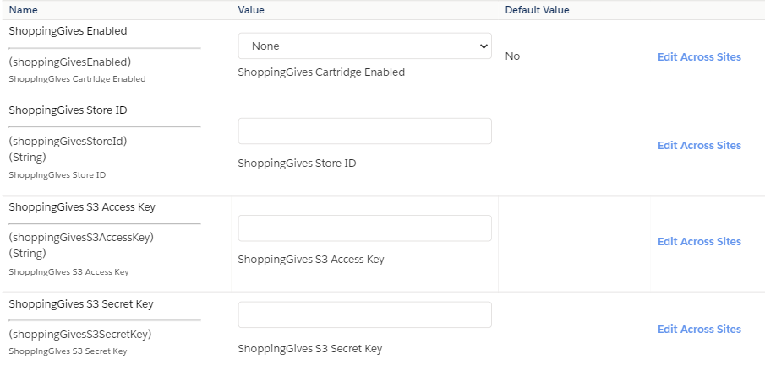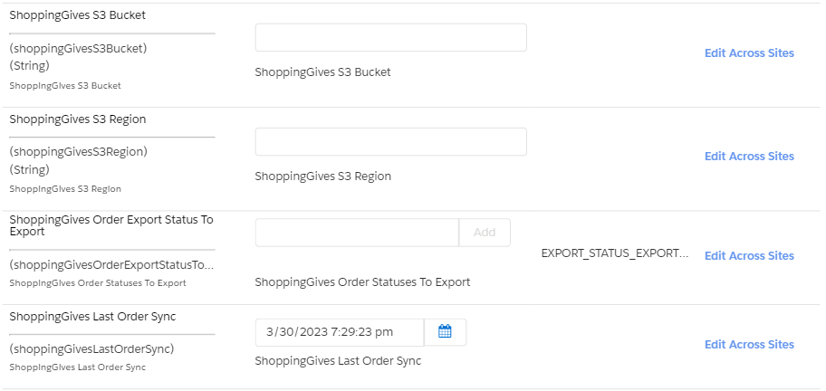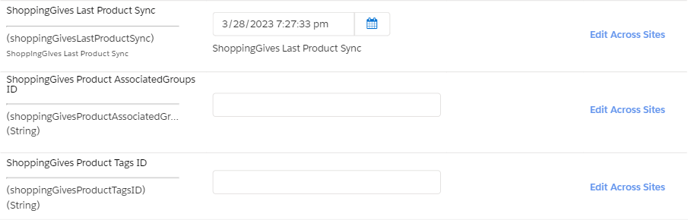

## Order Export Status to Export

It will export orders with export status configured in “ShoppingGivesOrderExportStatustoExport” in custom preference.  
Following are the allowed statuses:

* EXPORT_STATUS_EXPORTED
* EXPORT_STATUS_FAILED
* EXPORT_STATUS_NOTEXPORTED
* EXPORT_STATUS_READY

For more information visit [B2C documentation](https://documentation.b2c.commercecloud.salesforce.com/DOC2/index.jsp?topic=%2Fcom.demandware.dochelp%2FDWAPI%2Fscriptapi%2Fhtml%2Fapi%2Fclass_dw_order_Order.html&resultof=%22%6f%72%64%65%72%22%20%22%65%78%70%6f%72%74%22%20/)

## Configure Product Associated Group ID and Product Tags ID

To map Shopping Gives Product Associated Group Id or Product Tag Id to ETL, any product level custom or system attribute can be mapped. Product level custom or system attribute Id needs to be put in ShoppingGivesProductAssociatedGroupId or ShoppingGivesProductTagId. The data types allowed for these attributes are following as below.

* String
* Text
* Integer
* Number
* Boolean
* Quantity
* Set of String
* Set of Integer
* Set of Number
* Enum of String
* Enum of Integer

## Configure Shopping Gives Service Credentials

Importing the services.xml metadata file will create many Shopping Gives services, profiles, and credentials. Verify that the following exists.

**Services**

Normally these service definitions do not need to be modified.

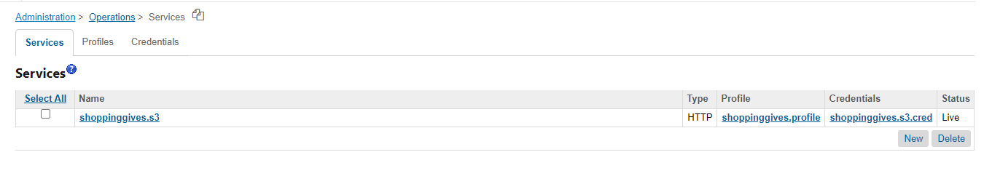

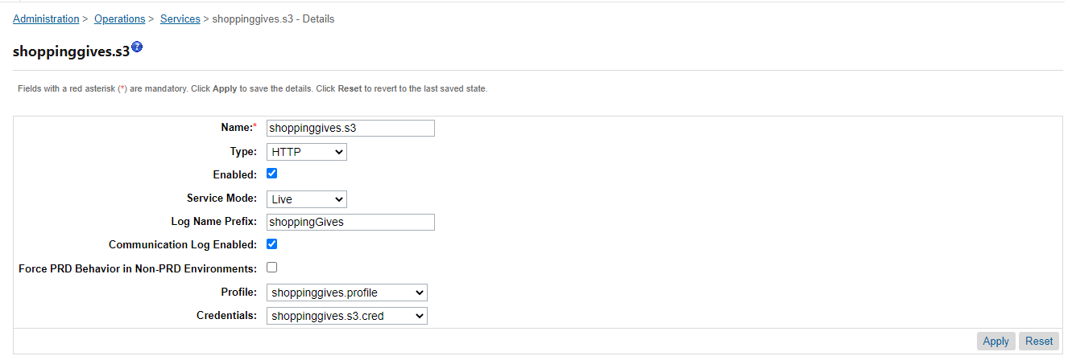

**Profiles**

Normally this profile definition does not need to be modified.

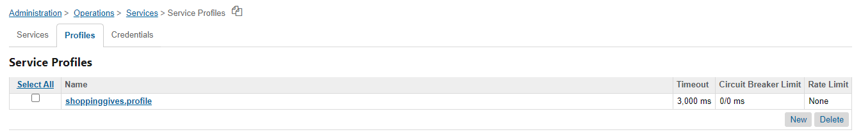

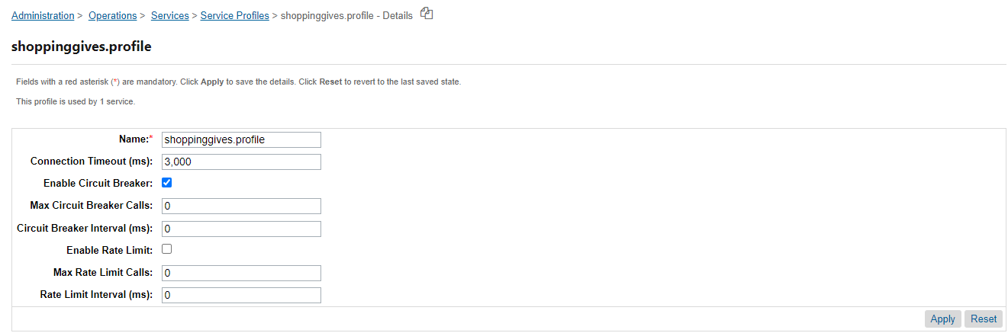

**Service Credentials**

Shopping Gives service credentials, found in Administration > Operations > Services > Service Credentials, should be updated with the information provided by your Shopping Gives representative.

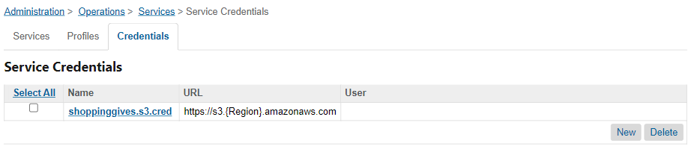  
For S3 Region and Credentials contact shopping gives support portal.

## Custom Code

The “int_shoppinggives_sg_changes” cartridge includes a template for shopping that gives tracking. These will work with a default SG installation but may need to be merged into your cartridge(s) if you’ve customized the same templates.

* + 1. int_shoppinggives_sg_changes\cartridge\templates\default\checkout\confirmation\confirmation.isml example template. And override the highlighted sniped code into your overridden app_storefront_base cartridge’s confirmation.isml template.



# Operations, Maintenance

## Data Storage

**Site Preferences** – the SitePreferences system object has been extended to store setup and confirmation values for each B2C Commerce site.

## Availability

This integration should work as expected as long as Shopping Gives itself is up and running.

The exportOrder job and the exportProduct job are optional but may be scheduled as required either individually or as part of the ShoppingGives FullProcess job.

## Failure/Recovery Process

When the cartridge is down then orders and products will not be exported. This will not affect the storefront and the storefront will work as expected.

## Support

For post-live support please submit a support ticket via the Shopping Gives support portal: <https://support.shoppinggives.com/>

# User Guide

## Roles, Responsibilities

There are no recurring tasks that need to be fulfilled to get the full potential of Shopping Gives other than the scheduled Jobs. As long as the configuration details are correct in your Site Preferences that is all you’ll need to do.

# Known Issues/Caveats

* *There are no known issues.*

# Release History

|  |  |
| --- | --- |
| **Version** | **Date** |
| 23.1.0 | 2023 |